Conduent Business Services
Americas Commercial and State Government
Transportation Solutions

Florida Centralized Customer Service System

CMMS User’s Guide
CMMS Procedures for use by All Parties
January 2018


©2017 Conduent Corporation Conduent® and Conduent and Design® are trademarks of Conduent Corporation in the United States and or other countries.

Other company trademarks are also acknowledged.

This document has been through a formal review process. To the best of our knowledge it is accurate. Conduent reserves the right to make further modifications as necessary.
This document is produced by Conduent Services, Inc. project management and cannot be reproduced or distributed to any third party without prior written consent

Version History
Version Number | Date | Description of Changes | Author
0.1 | 1/23/18 | Consolidated previous docs | LFS

Table of Contents

1 Overview 3
1.1 CMMS 3
1.2 Purpose 3
1.3 Authority 3
1.4 Audience 3
2 Accessing CMMS 4
2.1 Logging into CMMS 4
2.2 User Interface 4
3 Service Requestor View 5
4 MRO View 7
5 Servicing Work Orders (MRO View) 12
5.1 Updating a Work Order 12
5.2 Closing a Work Order 14

Overview
The Florida Centralized Customer Service System (FLCCSS) manages the toll operations for the state of Florida, and provides services for the following toll agencies (Agencies) within the state:
Florida’s Turnpike Enterprise (FTE)
Miami-Dade Expressway Authority (MDX)
Tampa Hillsborough Expressway Authority (THEA)

Conduent’s Vector is the back office system (BOS) that automates toll support. The computing environment for Vector is located in the TransCore data center in Orlando with a DR location in Suwanee, GA. Leapfrog Services provides infrastructure, desktop, and general first level support of the CCSS environment.

CMMS
CMMS, an application developed and marketed by Maintenance Connection, is the ITSM (IT Service Management) application for the FL CCSS environment. This CMMS instance is hosted internally at TransCore; Leapfrog supports the CMMS infrastructure and Conduent supports the CMMS application.

Purpose
The purpose of this document is provide “end user” usage procedures for opening and maintaining work orders in CMMS.
This document does not address CMMS administration or super-user features.

Authority
TBD

Audience
The audience is for Conduent, Leapfrog, and vendor personnel supporting the FL CCSS environment.

Accessing CMMS
CMMS is hosted in the FL CCSS environment.

Logging into CMMS
CMMS is not publicly accessible, so one will need to access from a FL CCSS location or via the FL CCSS VPN.
- From inside the TransCore network, browse to: http://10.32.34.94/mc_web/
- Log in with Maintenance Connection CMMS credentials
Those without a CMMS account can request as follows:
- From the login page, click the link for “Want to Sign Up? Click Here”
- Select the radio button for “I am NOT a Member of the Maintenance Connection” – click OK
- Enter the Connection Key: FLCSC – click OK
- Enter information and agree to the terms
- The account request will need to be approved by a CMMS administrator (this may take 48 hours)

User Interface
The CCSS CMMS application is accessed via two interfaces:
(1) The Service Requester method is a simple entry point into CMMS that allows one to open a work order or check status.
(2) The Maintenance, Repair & Operations Work Center interface is more complex but it allows the user to assign and close work orders and use other advanced features.
The Service Requester is the preferred method due to its ease-of-use and its economical usage of application licensing, but guidance for both options is presented below.
…

Service Requestor View
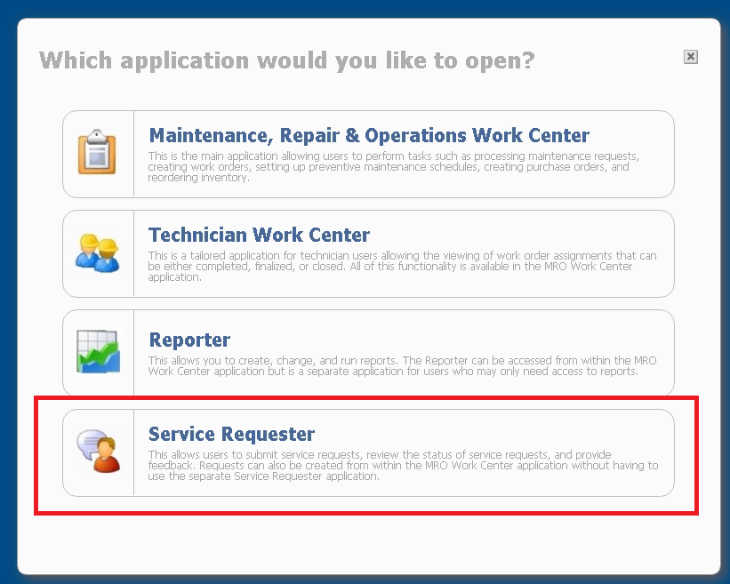
The Service Requester view will provide the feature set that most CMMS users require. Follow these procedures to access.

- Once one has logged into CMMS, one may be prompted to select an interface. Select “Service Requester” from this list (if not automatically directed the Service Requester view)

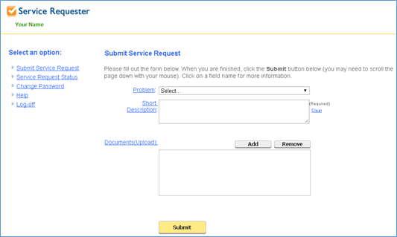
- The Service Requester view will display as follows:

- Please fill out the Service Request form with the relevant details
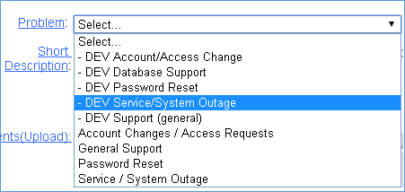
  - Problem – select a “problem” from the list of support categories. Requests for the development team should select one of the “DEV” categories to ensure that the work order routes to the correct group (particularly outside of EST business hours).

  - Short Description – please enter as much detail as possible to ensure proper handling of the work order. This includes specific details about the nature of the request/issue. Any details about the urgency or impact and any contact information, if different than your email address stored in CMMS
    - NOTE: urgent requests that represent system failures/outages should be reported via phone (Dial: 1-833-263-0469)
  - Documents (Upload) – (Optional) Any supplemental files/objects can be attached to the Service Request. This can be a screen capture of an error message, logs, spreadsheets – any standard document format of reasonable file size will be accepted.
  - Note on Access Requests: Requests for system/data access or permission modifications must be submitted by an approved individual from Conduent.
Leapfrog will deny and close any work orders in CMMS requesting access if not sent by one of the approved Conduent designees.

- Once all the details have been added, click the Submit button and the request form will populate a CMMS Work Order. The work order will be assigned to the appropriate team based off of the Problem/Category selection.
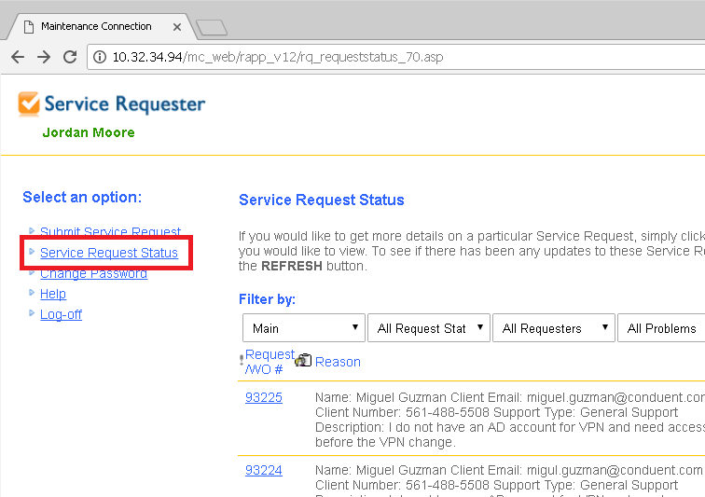
- To check on the status of one of an existing Service Requests, click the link for ”Service Request Status” on the left side of the screen. This will display all requests (made by that CMMS account) and current status of those requests. This view will not show requests made by colleagues.

MRO View
When the Service Requester is insufficient, the MRO (Maintenance, Repair & Operations Work Center) view provides full functionality. Follow these procedures.

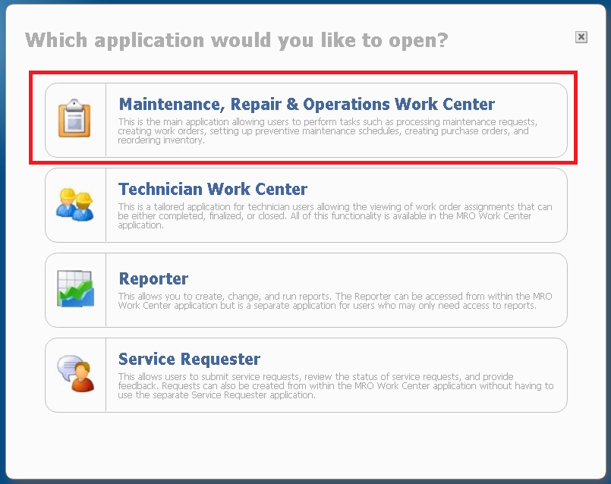
- Choose Maintenance, Repair & Operations Work Center

- Select “Work Orders” from the drop-down-list.

- Click “New” and select “Work Order” to create a new ticket.
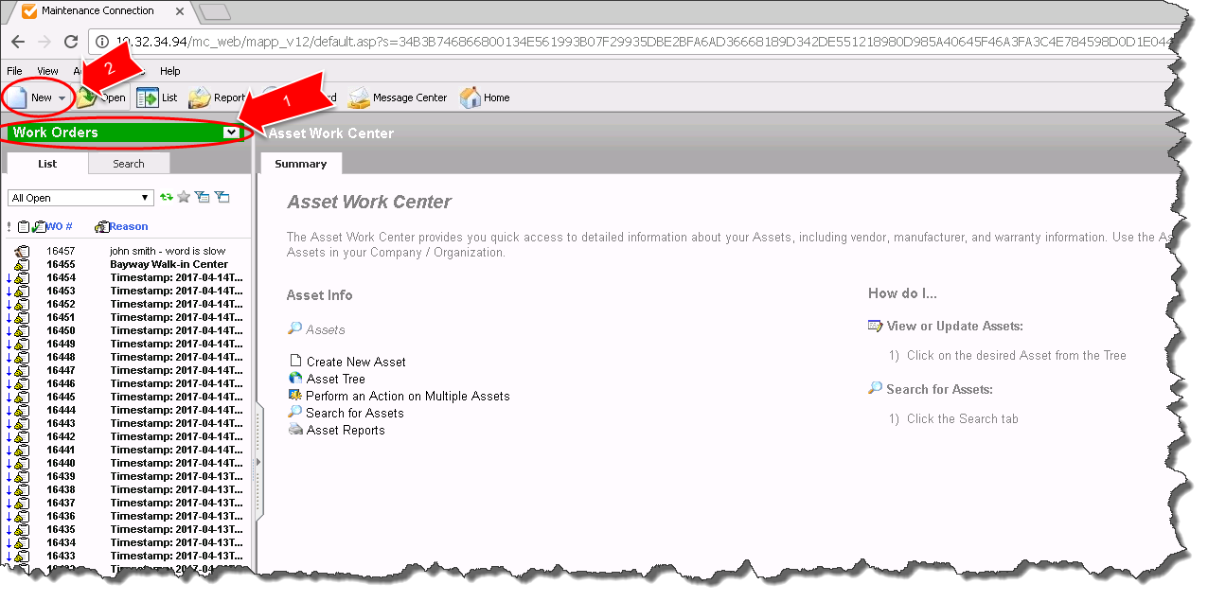

- In the Reason Code box enter the following.
Username – Summary of the issue
-------------------------------------------
Description/more details of the issue
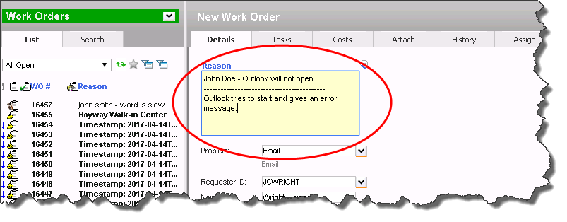
- Select Problem to select the Category of the issue.
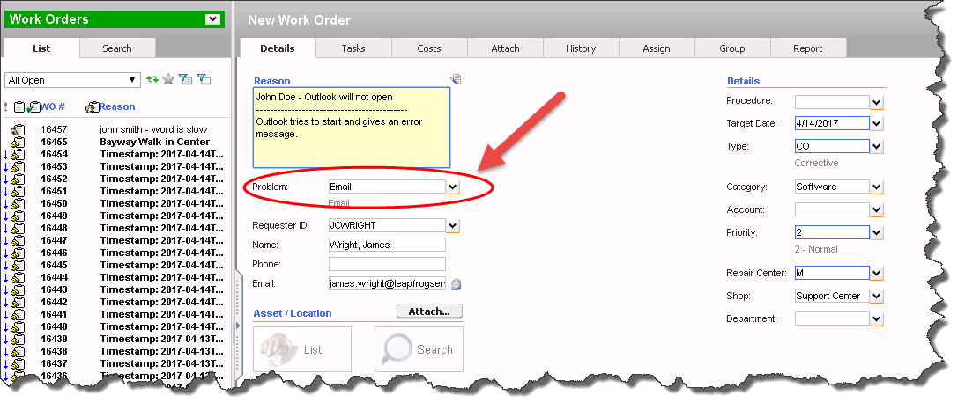
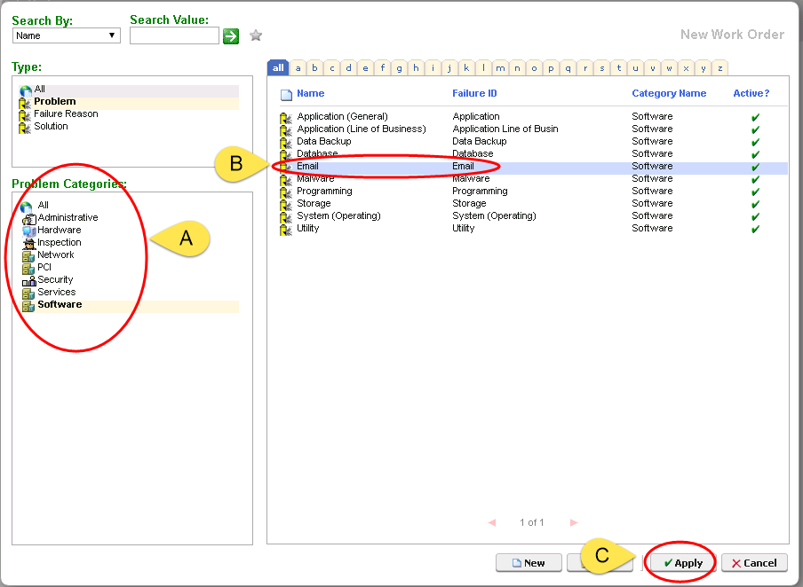
- From the pop up window, select the Category (A), Subcategory (B), then apply (C).

- Assign an asset to the ticket. Select Search or List to find and assign an asset. If this request involves multiple assets, select the location or the service (e.g., Primary Data Center or Vector).
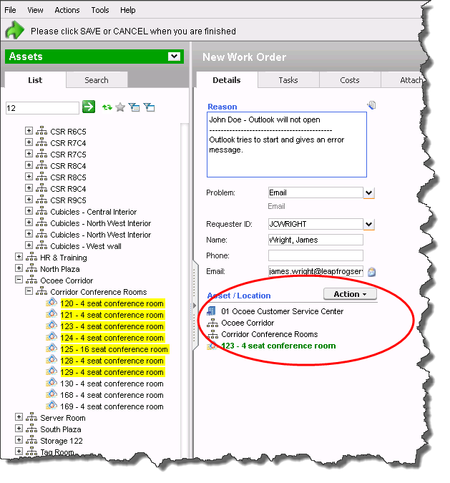
- Select the Ticket type. Typically this will be INCIDENT (something is not working as expected) or REQUEST (I need something new).
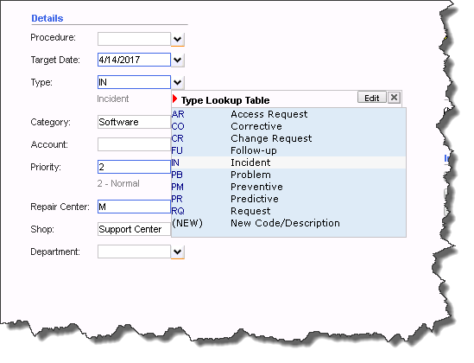

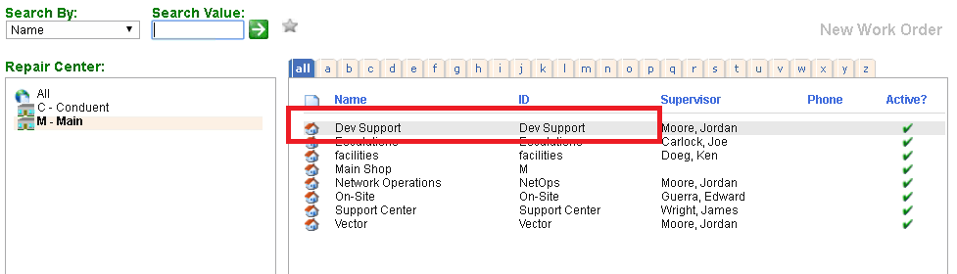
- Select the Shop to which the ticket will be issued.
Note: Most issues from the Development Team should be submitted to the shop “Dev Support”.

- Save your Work order.
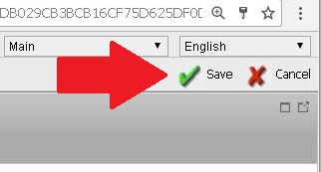
The Word Order number is displayed upon saving.
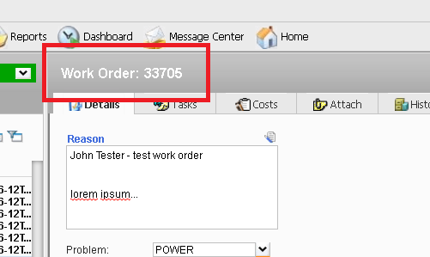

- Assign the ticket to a support engineer by selecting from the Assignments “Action” drop-down menu as follows.
For Dev Support issues, assign the ticket as follows.
  - During business hours IST (UTC +5.5 hours) – assign the ticket to “Pythian”
  - During business hours EST (UTC -5 hours) – assign the ticket to “LFS Dev Support”
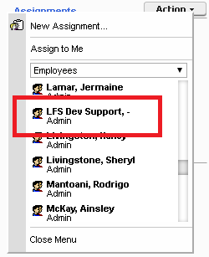
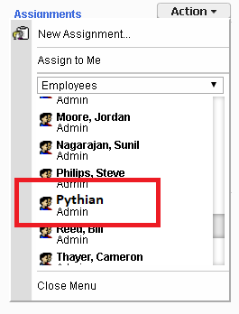
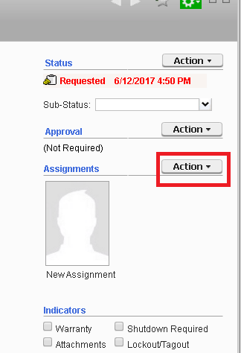

- After assigning the Work Order, click on other work orders, create new work orders, or log out of the system.

Servicing Work Orders (MRO View)

Updating a Work Order
Update work orders using the following procedures.
- Updating requester, categorization, priority, and the description in the Reason field of the ticket may be required for newly assigned tickets

- Ticket updates and notes should be added to the Costs tab.
This may be a little unintuitive, but it allows for tracking time spent on each task and it provides the full name of the person adding the task.

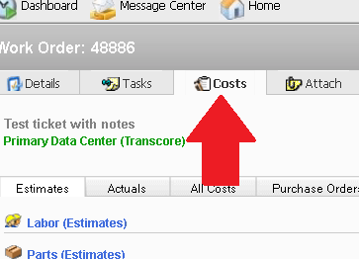
- In a Work Order go to the Costs Tab

- Select the Actuals tab and add an entry for Labor (Actuals).

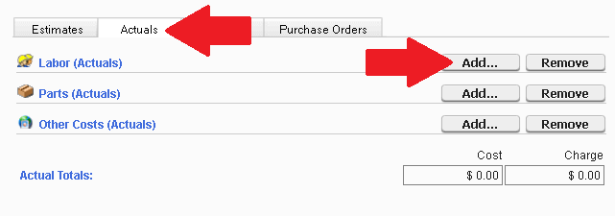

- Search for your own name (last-name) under the Employee type and click on your name.
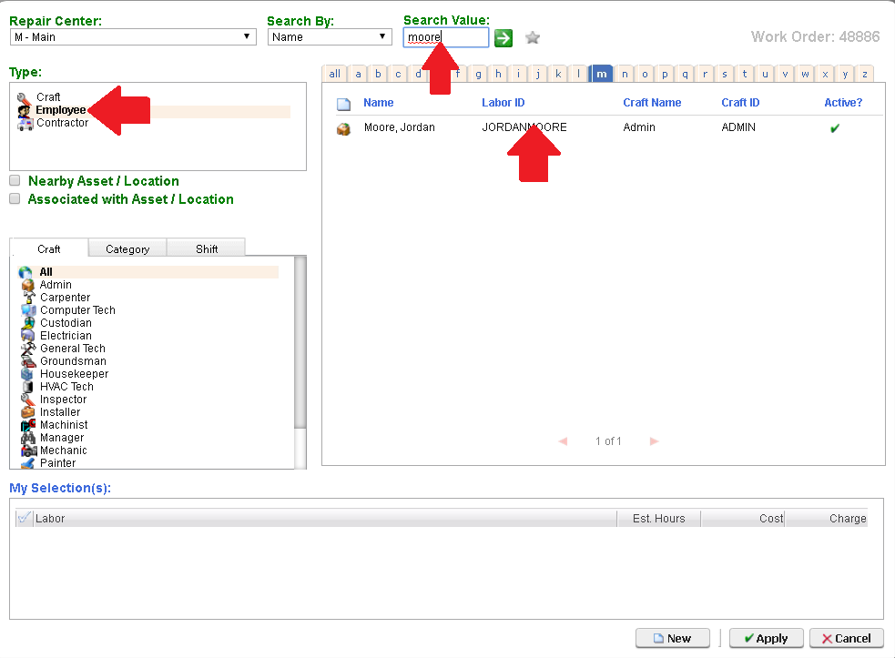
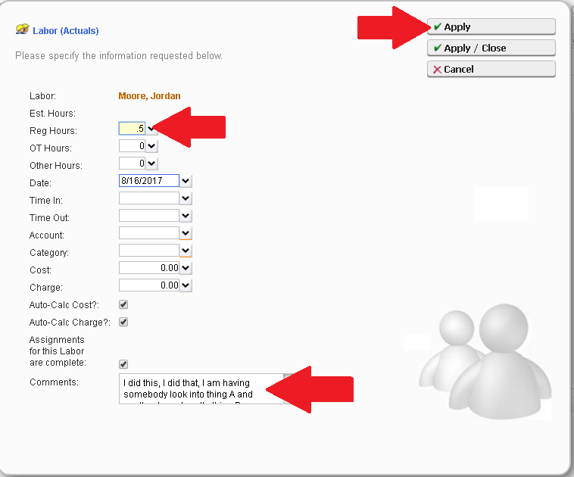
- This will bring up a window where you can add the time you spend on the task in question and a description of the work that has been done and/or current status of the work order and hit the Apply or Apply/Close button to update the entry

- After you save the Work Order the costs tab will display your notes and will list all subsequent notes in Chronological order. It should be noted that the entries are stamped with the date and not the time. If the time is important to the status you may want to manually enter that into the note
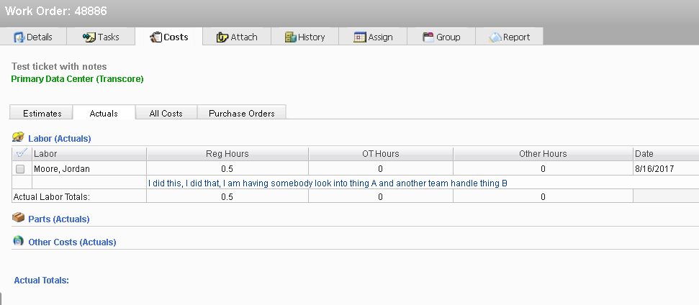

Closing a Work Order
Once all tasks have been handled and the requester informed, close work orders with the following procedures.

- Select Action and Complete/Close
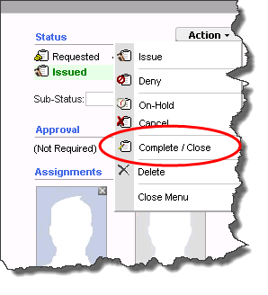

- In the pop up window, enter the close notes into the “Labor Report update” Field and check the “Close” checkbox then apply to close the ticket.
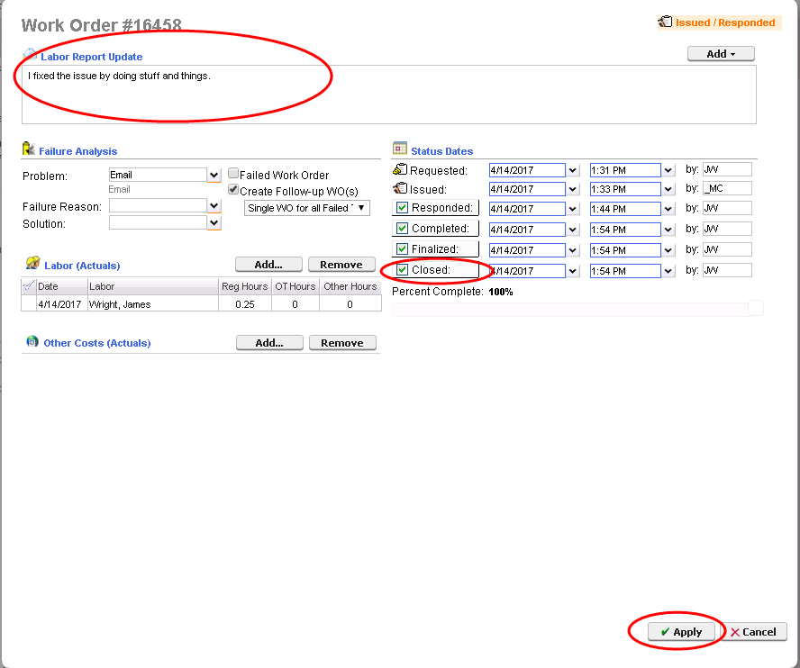
- The ticket is now closed
Note that CMMS does not notify requesters when work orders are closed, so any communication with the requester/end user must be direct.

